

**MATHEMATICS SPECIALIST 3,4**

**TEST 2 SECTION ONE 2016**

**NON Calculator Section**

**Chapters 3 and 4**

**Name________________________________ Time: 35 minutes**

**Total: 35 marks**

Question 1 (7 marks)

Two functions are defined as and 

(a) Evaluate  (2 marks)

(b) Find in simplified form . (2 marks)

(c) Determine the domain of  (3 marks)

Question 2 (6 marks)

(a) Determine the domain and range of  given that  and

 (3)

(b) Given that  and , find . (3)

Question 3 (6 marks)

The graph of function  for the domain  is shown below.



(a) Determine the exact value for  (2)

(b) On the axes given above, sketch the graph of the inverse function, (2)

(c) Obtain the rule for . (2)

Question 4 (5 marks)

A rational function  is sketched below. Function  has the following properties:

* Only one pole or a discontinuity at 
* Two horizontal intercepts at .
* A horizontal asymptote at 



(a) If  explain why 

(4)

(b) Determine .

(1)

Question 5 (7 marks)

Solve the following.

1.  (1)
2.  (2)

(c )  (2)

1.  (2)



**MATHEMATICS SPECIALIST 3,4**

**TEST 2 SECTION TWO 2016**

**Calculator Section**

**Chapters 3 and 4**

**Name________________________________ Time: 20 minutes**

**Total: 20 marks**

Question 1 (5 marks)

The function *f*, defined for all real *x* by , where *a* and *b* are positive integers, has the following graph.



1. Find the values of *a* and *b*.

(b) Express as a piecewise function.

Question 2 (5 marks)

At 10.00am, two bumper cars at the royal show, G and T, have position vectors, ***r*** m, and velocity vectors, ***v*** m/s, as shown below:





Prove that the bumper cars will collide if they continue with these velocities and find the time and location of the collision.

Question 3 (5 marks)

Sketch the graph , the asymptotes and describe the behaviour of the graph as  Give the equations for the vertical and other asymptotes.

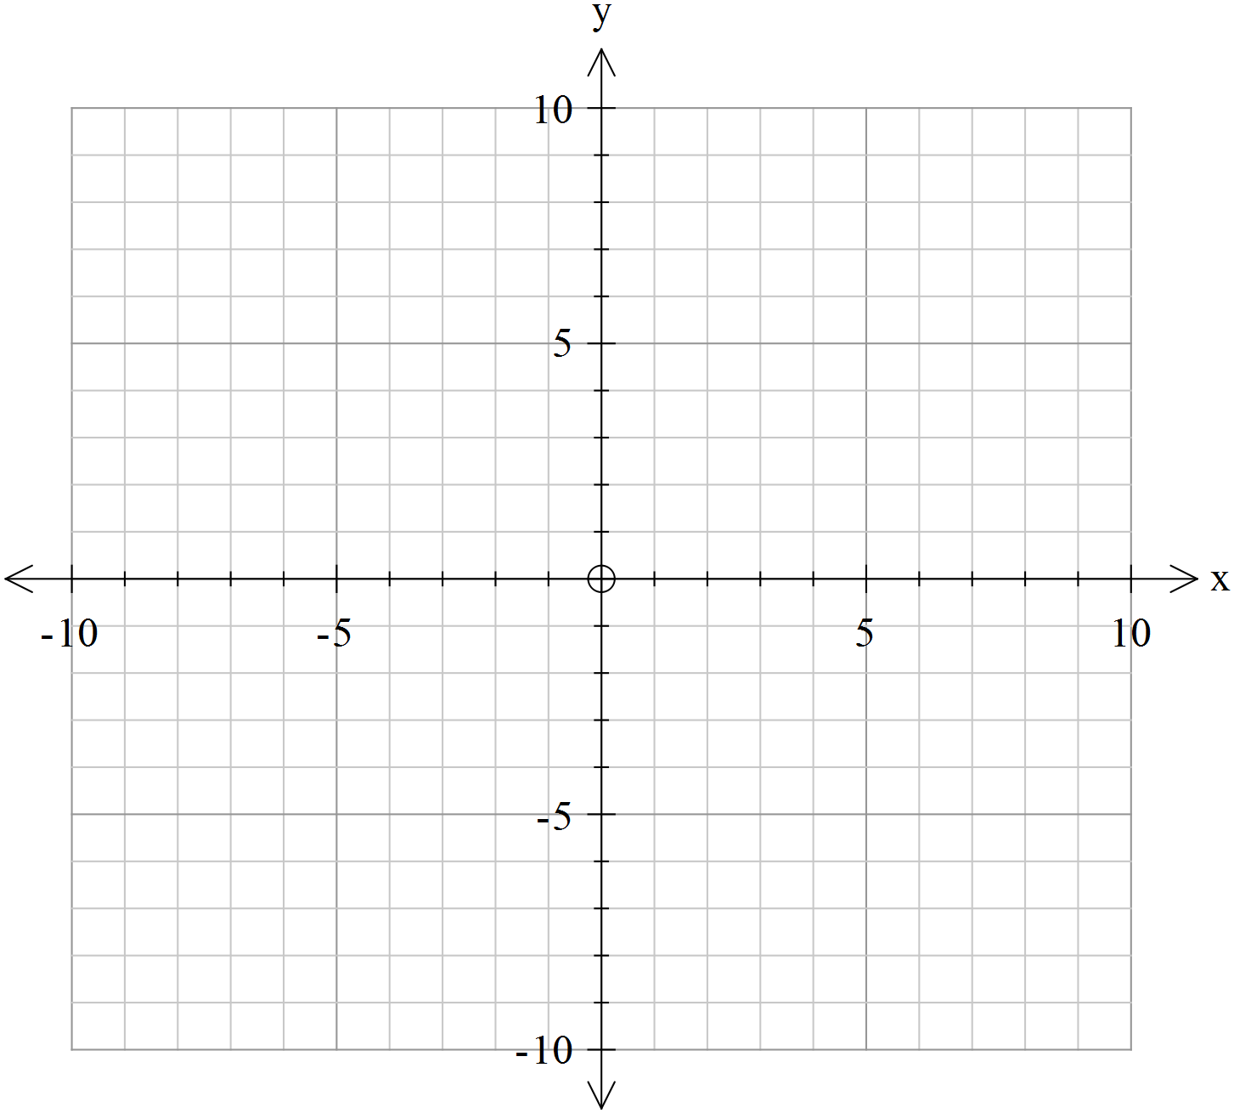

Question 4 (5 marks)

Find the Cartesian equation of the line perpendicular to the vector  and passing through the point 